**CDAC Mumbai PG-DAC AUGUST 24**

**MODULE 2 OOPJ**

**Assignment No- 2**

**1)Write a program that checks if a given year is a leap year or not using both if-else and switch-case.**

1. By If Else Loop :

import java.util.Scanner;

public class LeapYearIfElse {

public static void main(String[] args) {

Scanner sc=new Scanner (System.in);

int year;

System.out.println("Enter Year");

year=sc.nextInt();

if ( year % 400 == 0 ){

System.out.println(year+" is a Leap Year");

} else if ( year % 100 == 0){

System.out.println(year+" is a Leap Year");

} else if ( year % 4 == 0){

System.out.println(year + " is a Leap Year");

} else {

System.out.println(year+ "is Not a Leap Year");

}

}

}

**Output :**

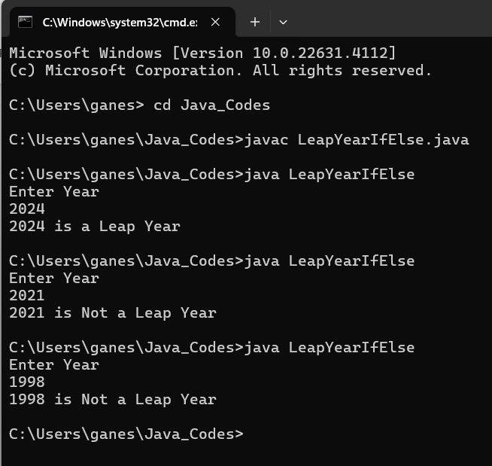

1. By Switch Case :

import java.util.Scanner;

public class LeapYearSwitchCase {

public static void main(String[] args) {

Scanner sc=new Scanner (System.in);

int year;

System.out.println("Enter Year");

year=sc.nextInt();

switch (year % 400 ) {

case 0:

System.out.println(year + " is Leap Year.");

break;

default:

switch (year % 100) {

case 0:

System.out.println(year + " is Leap Year.");

break;

default:

switch (year % 4 ){

case 0:

System.out.println(year + " is Leap Year.");

break;

default :

System.out.println(year + " is not Leap Year.");

}

}

}

}

}

Output:

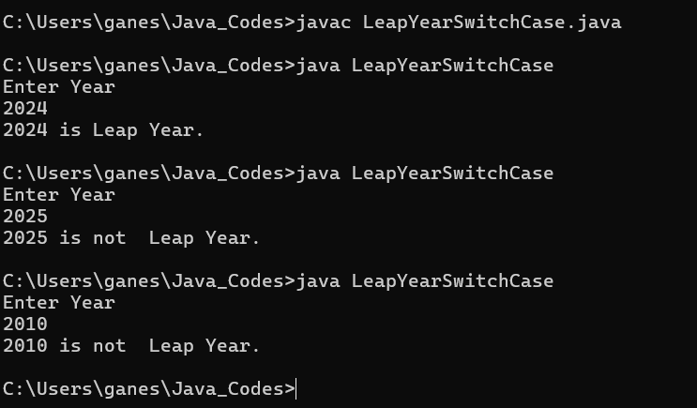

**2)Implement a program that calculates the Body Mass Index (BMI) based on height and weight input using if-else to classify the BMI int categories (underweight, normal weight, overweight,etc).**

import java.util.Scanner;

public class BodyMassIndex {

public static void main(String[] args) {

Scanner sc=new Scanner (System.in);

double weight, heightFeet, heightMeter;

System.out.print("Enter Weight in kg :");

weight=sc.nextDouble();

System.out.print("Enter height in Feet:");

heightFeet=sc.nextDouble();

heightMeter = (heightFeet * 0.3048);

double BMI;

BMI = (weight/ (heightMeter * heightMeter));

System.out.printf("Body Mass Index is : %.2f ", BMI);

System.out.println();

if ( BMI >=25 ){

System.out.println("You are in Overweight");

} else if (BMI < 25 && BMI >= 18.5){

System.out.println("you are in NormalWeight");

} else {

System.out.println("you are in UnderWeight");

}

}

}

**Output :**

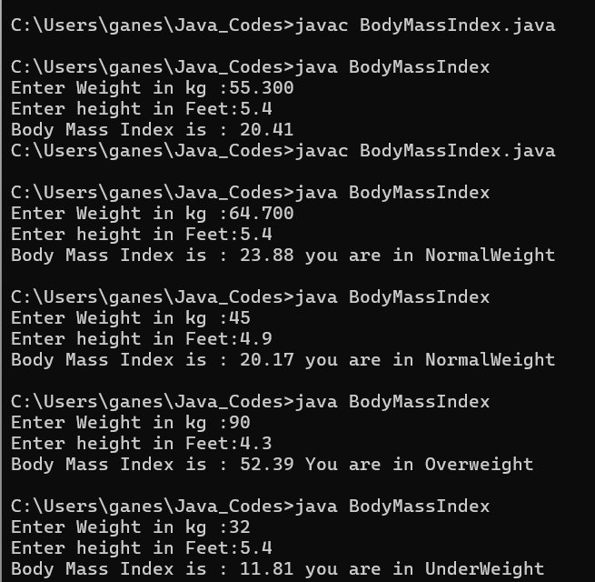

**3)Write a program that checks if a person is eligible to vote based on their age.**

import java.util.Scanner;

public class VoteAge {

public static void main(String[] args) {

Scanner sc=new Scanner (System.in);

int Age;

System.out.print("Enter Age :");

Age=sc.nextInt();

if (Age >= 18){

System.out.println("Eligible for Voting");

} else {

System.out.println("Not eligible for Voting ");

}

}

}

Output:

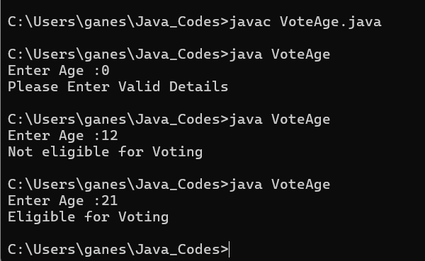

**4)Write a program that takes a month (1-12) and prints the corresponding season (Winter, Spring, Summer, Autumn) using a switch case**

import java.util.Scanner;

public class Season {

public static void main(String[] args) {

Scanner sc=new Scanner (System.in);

int Month;

System.out.print("Enter Month :");

Month=sc.nextInt();

switch (Month) {

case 12,1,2 :

System.out.println("Season is Winter");

break;

case 3,4,5:

System.out.println("Season is Spring");

break;

case 6,7,8 :

System.out.println("Season is Summer");

break;

case 9,10,11:

System.out.println("Season is Autumn");

break;

default :

System.out.println("Please Enter Valid Month");

}

}

}

**Output:**

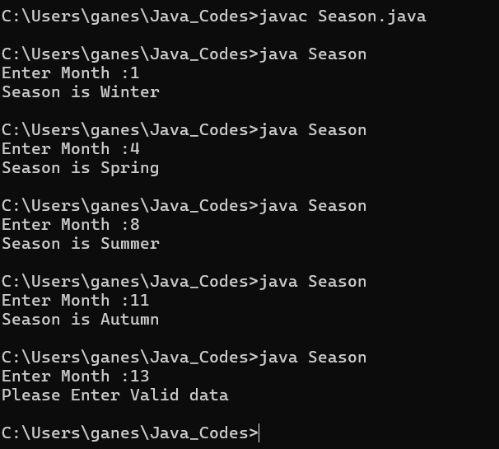

**5)Write a program that allows the user to select a shape (Circle, Square, Rectangle, Triangle) and then calculates the area based on user-provided dimensions using a switch case.**

import java.util.Scanner;

public class ShapeDimension {

public static void main(String[] args) {

Scanner sc=new Scanner (System.in);

int Choice;

System.out.println("Select option ");

System.out.println("1. Circle");

System.out.println("2. Square ");

System.out.println ("3. Rectangle" );

System.out.println ("4. Triangle ");

System.out.print("Enter your Choice: ");

Choice =sc.nextInt();

System.out.println();

switch (Choice){

case 1:

float radius;

System.out.print("\n Enter Radius for Circle: ");

radius=sc.nextFloat();

float Ciarea=( (float)3.14 * radius * radius );

System.out.println("\n Area of Circle for Radius "+ radius +" is " + Ciarea);

break;

case 2:

float Length;

System.out.print("\nEnter Length of Square : ");

Length=sc.nextFloat();

float SqArea=(Length * Length);

System.out.println("\n Area of Square for length "+ Length +" is " + SqArea);

break;

case 3:

float Length1, Breadth;

System.out.print("\nEnter Length of Rectangle : " );

Length1=sc.nextFloat();

System.out.print("\n Enter Breadth of Rectangle: ");

Breadth=sc.nextFloat();

float RecArea=(Length1 * Breadth);

System.out.println("\n Area of Rectangle for length "+ Length1 +" and Breadth " + Breadth + " is: " + RecArea);

break;

case 4:

System.out.print("\n Enter Length of Tringle:" );

float Base, Height;

Base=sc.nextFloat();

System.out.print("\n Enter Height of Tringle: ");

Height=sc.nextFloat();

float TriArea=( (float)0.5 * Base * Height);

System.out.print("\n Area of Tringle for Base "+ Base + " and Height "+ Height + " is: " + TriArea);

break;

default :

System.out.println("\n Please Enter Valid Choice. ");

}

}

}

**Output:**

